

Embedded Systems Professional Track EgFWD - Udacity

# On-demand Traffic Light control

Project Documentation

By:

Mahmoud Ayman Ibrahim

I

## Table of Contents

Table of Contents .................................................................................................................

1. System Description ...................................................................................................... 3
   1. System Overview ................................................................................................. 3
   2. System Functionality ........................................................................................... 3
2. System Design .............................................................................................................. 4
   1. System Requirements .......................................................................................... 4
   2. Input & Output Formats ....................................................................................... 4
3. Flow Chart .................................................................................................................... 5

1. **System Description**
   1. **System overview**

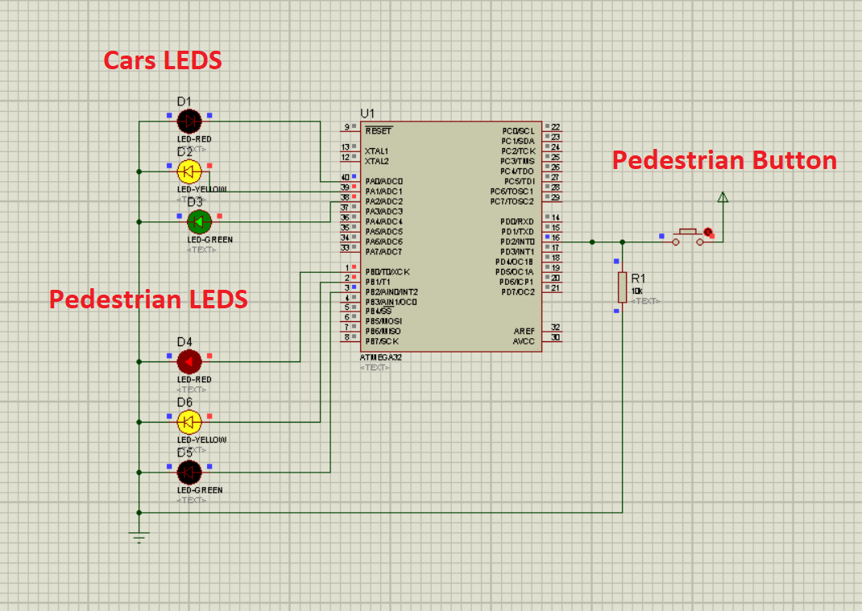

**1.2 System Functionality**

The system aim is to provide an on-demand traffic control device that include a pedestrian push button for the pedestrians to pass. The system detects the current state of car traffic light and when the button is pressed it will decide what to do on the pedestrians traffic light based on the current state of car traffic light to allow the pedestrians to walk safely by making sure that cars are stopped.

1. **System Design**
   1. **System Requirements**

The system composed of:

* AVR ATmega32 (1MHz)
* 6 LEDs
* 2 greens
* 2 reds
* 2 yellows
* 1 push Button
* 10k Ω resistance
  1. **Input & Output Formats**

System input is the pedestrian push button on pin number 2 (Port D), while the output is the 3 cars LEDs on pin numbers 1,2 and 3 (Port A)

And the 3 pedestrian LEDs on pin numbers 1,2 and 3 (Port B).

1. **Flow Chart**